LESSON 8: WOULD YOU LIKE KAYAKING?

I. VOCABULARY
a. Match the pictures with the correct activities.
1. □ kayaking 2. □ snowboarding 9. river rafting
3. □ skydiving 4. □ bungee jumping 10. mountain biking
5. □skateboarding 6. □ rocking climbing
7. □ jet skiing 8. □ surfing
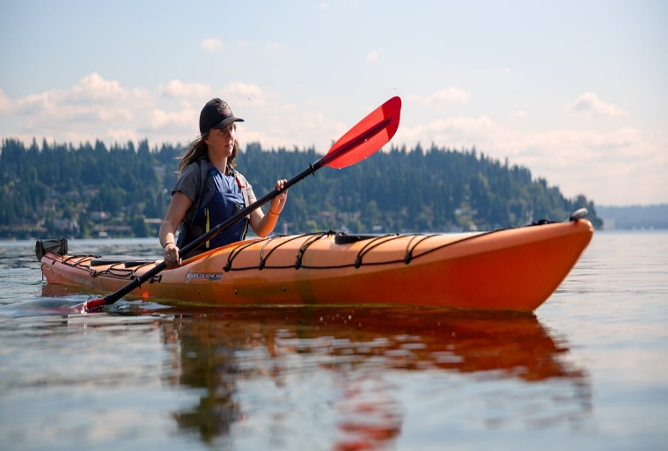
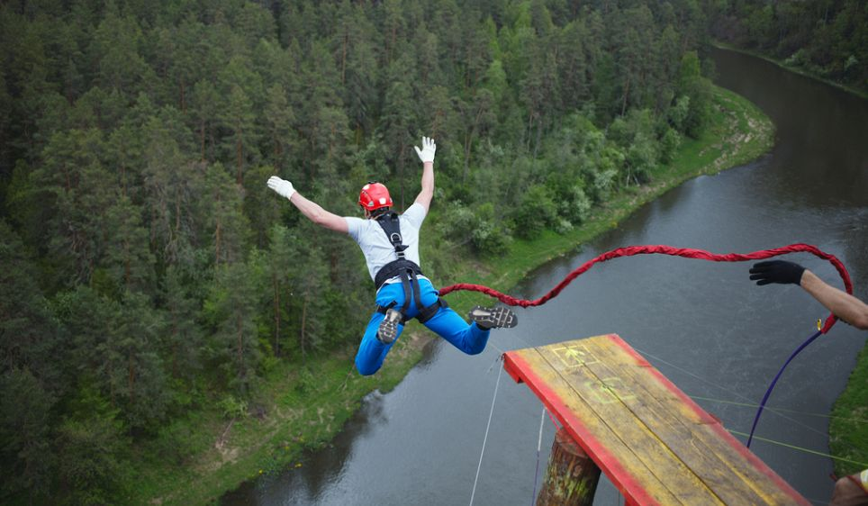
a
b

c
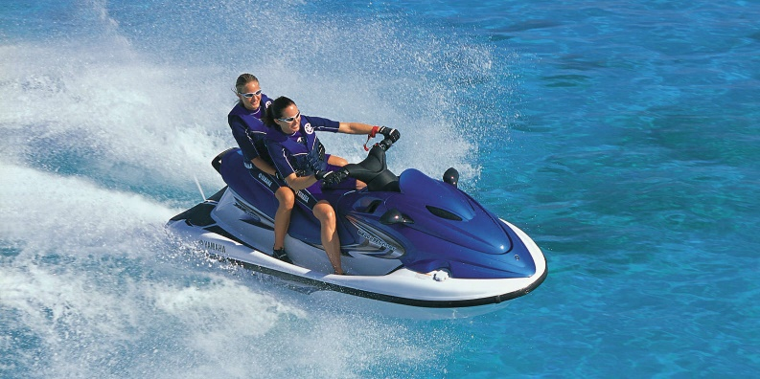
d
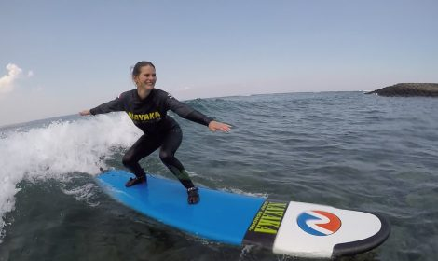

f

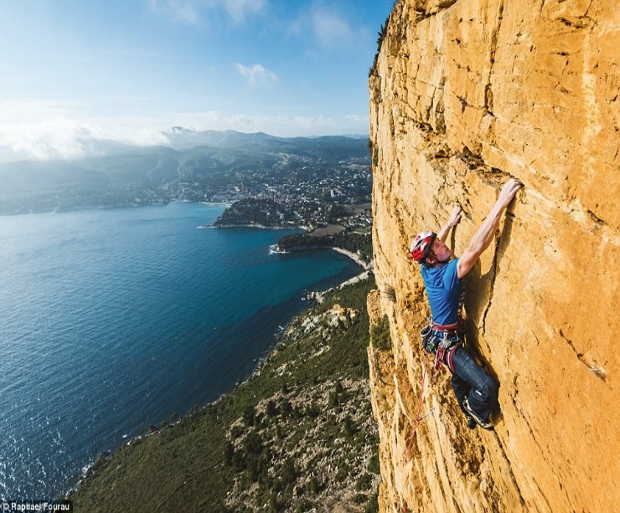
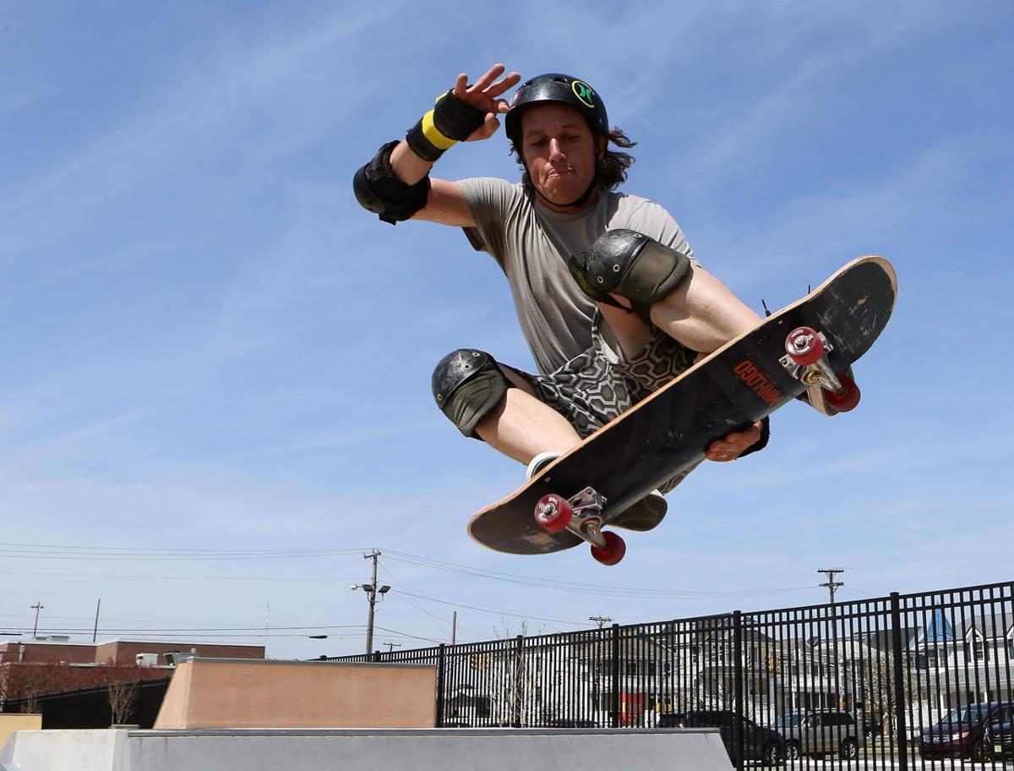
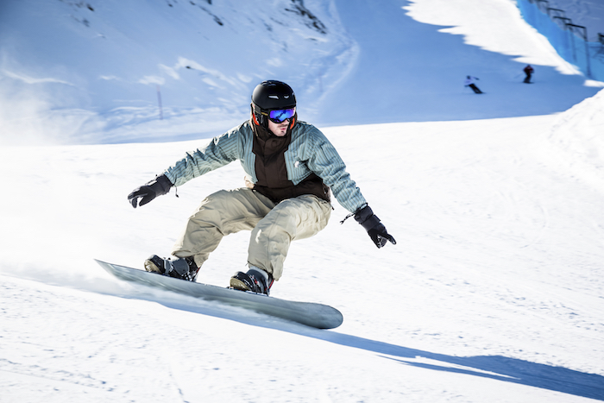
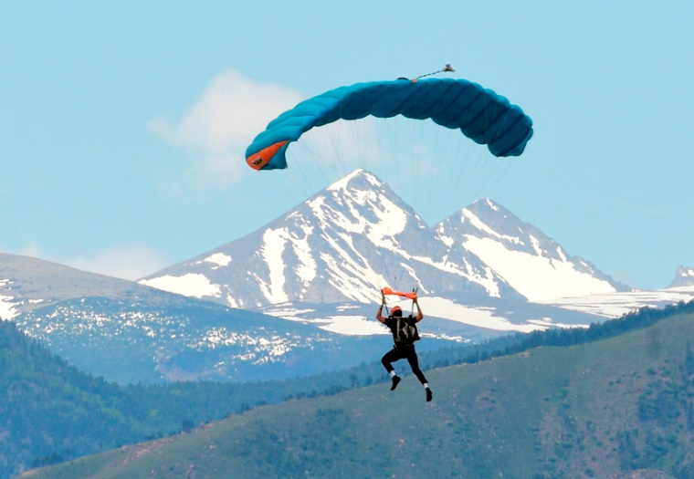
h
g
e

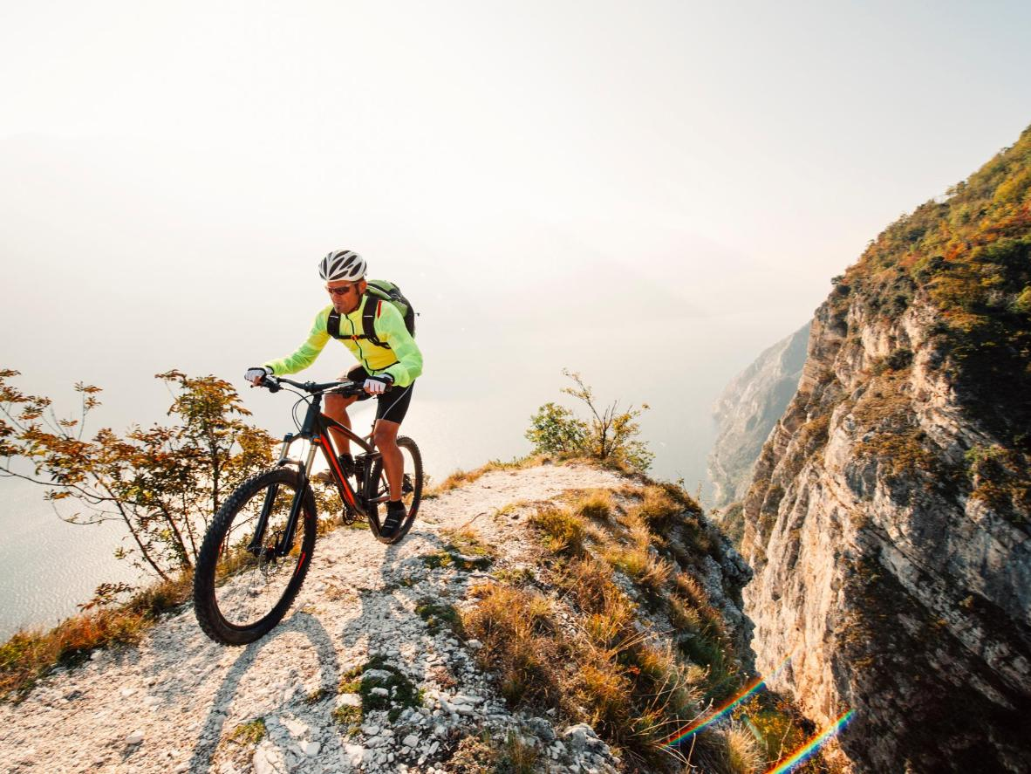
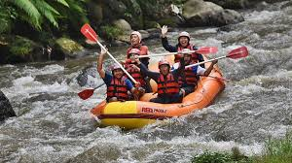
j
i

